Bazant’s M7 microplane model
- Compressive volumetric stress-strain boundary:
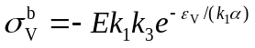
k₁=1.5×10⁻⁴; k₃=30; k₄=100; k₅=1.0×10⁻⁴; c₂₀=1.8; c₂₁=250.
- Compressive deviatoric stress-strain boundary:
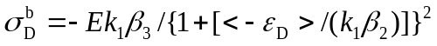
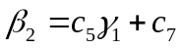
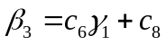
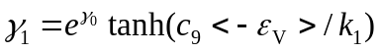
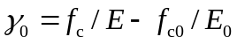
f_{c0}=15.08; E₀=20000; c₅=3500; c₆=20; c₇=1; c₈=8; c₉=1.2×10⁻².
- Trail of elastic normal stress:
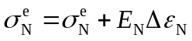
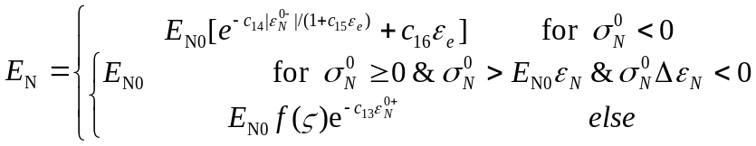
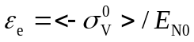
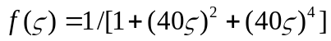
c₁₃=4500; c₁₄=300; c₁₅=4000; c₁₆=60.
- Tensile normal stress-strain boundary:
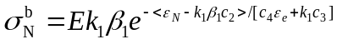
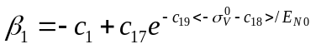
c₁=8.886×10⁻²; c₂=0.176; c₃=4; c₄=50; c₁₇=1.7; c₁₈=25; c₁₉=1000.
- Shear stress-strain boundary:
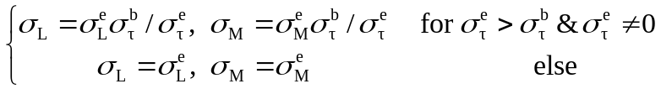
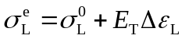； 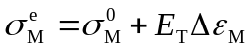
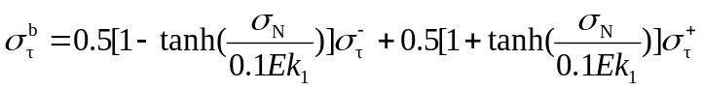
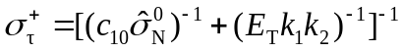
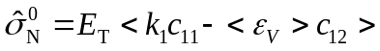
k₂=110; c₁₀=0.33; c₁₁=0.5; c₁₂=2.3597.

